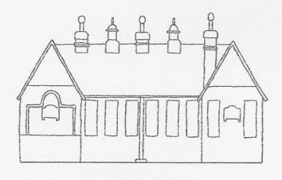

Ysgol Gynradd
Llangan
Primary School
Headteacher: Miss Sue Price
Llangan▪Cowbridge▪Vale of Glamorgan▪CF35 5DR▪Tel & Fax: 01446 772403
Email: llanganps@valeofglamorgan.gov.uk Website: www.llanganprimaryschool.co.uk
Twitter:@llanganprimary

18th May 2018

Dear Parents,

Newsletter and photo consent

Due to the General Data Protection Regulations that come into force on the 25th May we require parents to provide updated photo consent for each child. We also require consent from parents to continue receiving emails, text messages and our newsletters electronically.
Therefore I would be grateful if you would complete sections 1 and 2 and return to school by Thursday 24th May 2018. If we do not receive your consent by this date, we will be unable to continue sending information electronically until we receive your consent.

Should you have any queries regarding this please contact the school.

Many thanks,

Miss S Price
Headteacher

Section 1
Photo Consent
We occasionally use photographs of the children to celebrate their experiences and successes. Therefore please tick the options to indicate how we may use photographs of your child for this purpose.
Name of child: _______________________________Year Group:_______

 | Yes (√) | No (√)
May we use your child’s photo in our newsletters?
May we use your child’s photo on our website/ Twitter?
May we use your child’s photo in our prospectus?
May we use your child’s photo in local media/press publications?
May we provide consent to 3rd party organisations to use for their publicity (such as Give Racism the Red Card, Cycling Proficiency etc)?

Please note: School permits parents to take photographs of their child during school events such as sports day for their personal use. However these must not be shared on social media or other publications. Failure to adhere to this policy may result in the school implementing a blanket ban.
Section 2
Newsletter, emails and text messages
For many families we hold two contacts that receive electronic communication from the school. Therefore please ensure that both parents complete the authorisation below. Where this is not practical please contact school and we shall arrange an alternative method to obtain the consent. Please note this does not apply to emergency contact information where school may hold more than two contacts.
Parent 1
If you wish to continue receiving emails, text messages and our newsletter electronically please tick (√) the box □
Name of parent__________________________________

Signed _________________________ Date_________________________

Parent 2

If you wish to continue receiving emails, text messages and our newsletter electronically please tick (√) the box □

Name of parent__________________________________

Signed _________________________ Date_________________________

